NETWORKING 4

Response codes • For simpler automated processing of responses, they start with 3-digit number • The first digit expresses response severity: 1xx positive preliminary reply (action was started, further responses expected) 2xx positive completion reply 3xx positive intermediate reply (further commands necessary) 4xx transient negative completion reply (action failed, however repeating later makes sense) 5xx permanent negative completion reply (action failed and will fail later, too) • A similar schema adopted by many protocols
FTP was one of the first protocols designed to identify responses with a three-digit code, where the first digit expresses the nature of the response. This method allows clients to easily process responses without having to analyze the text of the response, which can also be localized into another language.
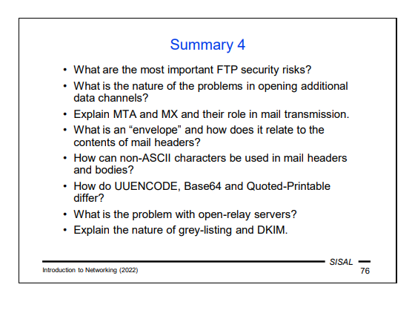

The most important FTP security risk is that it authenticates users by sending the passwords in the clear.

Nature of the problems in opening additional data channels?
both parties have to agree on who will open the data channel and to which address and port the connection should be established.

MTA and MX and role in mail transmission
Each node that receives and delivers mail is called a Mail Transfer Agent (MTA). Individual MTAs forward the message using the SMTP protocol, where the sending MTA temporarily acts as a client and the receiving MTA as a server. If the server is not the final destination, it queues the message and periodically attempts to deliver it to the next MTA.
MX records contain the name of the mail exchanger that is temporarily or permanently authorized to receive mail for a given machine or domain plus its priority (the lower the number, the higher the priority). In such a case, the delivering MTA sequentially tries to contact individual exchangers, according to priorities, until it succeeds.

What is an envelope and how does it relate to the contents of mail-headers?
The envelope is made of the addresses used in the protocol as the sender's and recipients' addresses. There is no relation between this envelope and the contents of mail-headers.
-----There is none! The addresses used in the protocol are called the envelope, and their relationship to the body of the message is the same as that of
the address written on a real mail envelope and the addresses written on the message inserted in the envelope. It is simply just text that the sender can fake; however, unfortunately, your mail program is then driven by it…

How can non-ASCII characters be used in mail-headers and bodies?
Through the extension of the SMTP protocol called ESMTP, in which the client and server can agree that both are able to accept 8-bit characters –the client can then use the so-called 8-bit content transfer encoding.

How do UUENCODE, Base64 and Quoted Printable differ?
In UUENCODE encoding, three bytes of the original file are taken, these 24 bits are divided into four groups of six bits, and these six-bit codes are converted to four printable characters using a fixed table. The encoded file is therefore 33 % larger than the original.
MIME defines two basic encoding methods:
• The method called Base64 is essentially nothing more than the old known UUENCODE. MIME only replaced the original coding table with a more modern one (today's computers do not have a problem with lowercase and uppercase messages, which gives us 52 characters instead of 26 and if we add digits, we

need to add only two non-alphanumeric characters, plus and slash) and slightly changed the line format.
• The Quoted-Printable method is mainly used for text files, where most of the text consists of ASCII characters. Each non-ASCII character is converted to the sequence "=HH", where HH is the hexadecimal value of the character (e.g. the equal sign itself must be encoded as "=3D"). The advantage over Base64 is that the text remains at least a little bit readable. From the point of view of coding efficiency, the ratio of ASCII and non-ASCII characters is important –if we encode text containing only non-ASCII characters, we will get a code size of 300 % of the original (compared to fixed 133 % for Base64), and for a pure ASCII text we get only slightly above 100 %.

What is the problem with open-relay servers?
there is a risk of misuse for sending mass emails and blocking of the communication by some other servers knowing about this misconfiguration.
------- If the server allows anyone to connect and send a mail anywhere, it is called an open-relay server and runs the risk of being misused to send bulk mail. Spammers try to cover their tracks by forwarding mail via several open-relay servers, so finding the real originator is complicated. Conversely, there are organizations that scan servers around the world, look for those that are open-relay, and compile a list of them that mail server administrators can use to block the receipt of mails from any of the open-relay servers.

------- Since the transmission of a message between the sender and the recipient is not a matter of a single connection, but the message is stored several times along the way, the question of securing the content of the message is entirely a matter for the end users. Therefore, the connection between MTAs is usually not encrypted in any way. However, there are exceptions –e.g. if we have two corporate mail servers connected by a public network, it makes sense to encrypt the connection between them so that all corporate mails do not have to be encrypted by their senders. The ESMTP extension includes a STARTTLS command that asks the server to start encryption using the Transport Layer Security interlayer.

Grey-listing and DKIM
They are both methods used for detecting spam in electronic mail communications.
The grey-listing method uses protocol properties and the experience that spam machines do not check delivery success. The server will therefore respond to the first attempt to deliver a message to a recipient, from a sender, and coming from an IP address with the 450 response to the RCPT TO command. If it was a genuine message, the client will attempt a new delivery after a certain time (typically 15 minutes), the server will discover that there has been a repeated attempt, and the new request will be answered normally with a 250 response and the message will be delivered.
------- As a result, if two partners exchange at least one message a month, their communication is carried out without delay, except for the 15-minute delay of the first message. If, on the other hand, there is no repeated attempt after the first one (e.g. within 1 hour), the triplet will be blacklisted for a period of time. It was the combination of black and white list ideas that gave the method its name.
DKIM -> a sending machine digitally signs all mails. More specifically, it signs the mail body and selected headers. The receiving server checks the signature and, as a result, either delivers the message to the destination mailbox or rejects it. Compared to SPF, this solution has the advantage that forwarding does not affect the signature in any way. All sending MTAs for a given domain can be equipped with a separate key, so that sending can be distributed to multiple machines and the list of them changed flexibly.

--------- Another way to solve the problem was the so-called Sender Policy Framework. The basic idea is simple: a domain defines a list of servers it uses to send mails, and no server in the world should accept mails whose sender is someone from that domain coming from a client not listed here. Relatively complex syntax rules were developed on how to define the correct sending MTAs, and these were formerly published using the DNS TXT record, later even with the newly created SPF record. But the catch to the principle is that once a message arrives somewhere where a user has set forwarding of incoming mails to a different location, the verification fails because the message with the original sender is suddenly being sent by a different machine! While correction mechanisms were established, the entire system proved to be inflexible, so that the DNS SPF type has been even withdrawn.
However, a more successful replacement was created, the so-called DomainKeys Identified Mail. The basic idea is the same; the difference is that a sending machine digitally signs all mails.
Various spams blockers are also a common means of protection. These are algorithms that attempt to estimate the probability that a message is spam. They use a number of attributes that a local administrator can give its own weights to. Attributes relate to both form (e.g. Subject in capital messages) and content (e.g. the frequency of some words). Based on the resulting score, the message can either be completely discarded, quarantined, or just tagged and delivered. Unfortunately, these algorithms are debatable in their effectiveness, because spam machines are increasingly adept at mimicking real messages, while strict rules increase the percentage of wrongly misclassified messages (so-called false positive outcomes).

